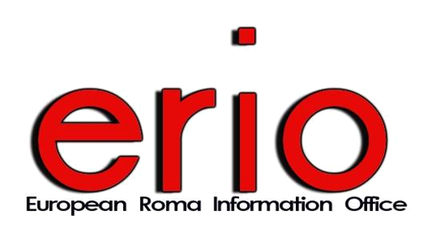
C O N F E R E N C E
ROMA MIGRATION
A European Challenge

27 May 2009 - 9.30 / 17.30
European Economic and Social Committee, Room VMA 3
2 rue Van Maerlant, 1040 Brussels

09:30 → Opening remarks
- Ivan Ivanov, Executive Director, ERIO
- Mr. Mario Sepi, President of the European Economic and Social Committee

09:45 – 10:45 → Non-Discrimination and Migration
- European Commission DG Justice and Home Affairs
- European Commission DG Employment and Social Affairs
- Fundamental Rights Agency

10:45 – 11:00 → Discussion

11:00 – 11:30 → Coffee break

11:30 – 12:30 → Solutions for protecting the rights of Roma Migrants, EU Roma Policy
- European Commission
- EU Presidency
- ENAR

12:30 – 12:45 → Discussion

13:00 – 14:00 → Lunch

14:00 – 14:45 → Roma and Border Crossing in Europe. Problematic practices concerning Roma migrants including Roma EU citizens.
- OSI
- ERRC
- ERIO

14:45 – 15:45 → Discussion

15:45 – 16:00 → Coffee break

16:00 – 17:00 → Sharing experience and good practices
- International Society
- IOM

17:00 – 17:15 → Discussion

17:15 – 17:30 → Closing Remarks

