
 | 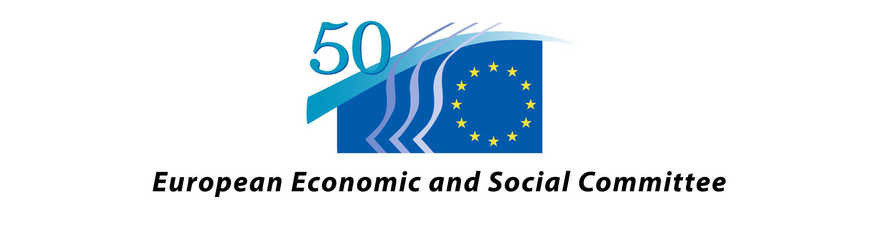 | 

REGISTRATION FORM

Roma Migration: a European Challenge

ERIO Conference, 27 May 2009
9.30 / 17.30

European Economic and Social Committee, 2 rue Van Maerlant, 1040 Brussels
Room VMA 3

I will participate: yes ⁮ no ⁮

Family name: Given name:

Personal ID: …………………………………………………………
(necessary for the security and registration for entering the conference)

Title, position:

Organization,
Institution:

Work address:

Tel / Fax:

E-mail:

Please complete the form and return to registration@erionet.org Tel .: 0032-2-733-34-62 Fax : 0032-2-733-38-75 . No later than 20 May.

